Main concept:

‘this’ is ***undefined*** in a function invocation in strict mode.

Available starting ES5.1

* Restricted variant of JS
* Better security and stronger error checking

Enabling strict mode

* Place the directive ‘use strict’ at the top of a function body
  + Strict mode is active not only in the current scope but also in all inner scopes!
* Execution context is NOT the global object anymore. It will be undefined.

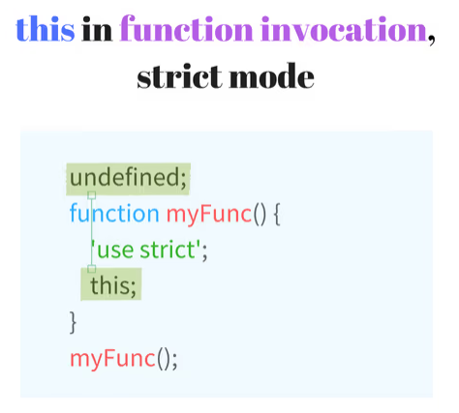

Example Code

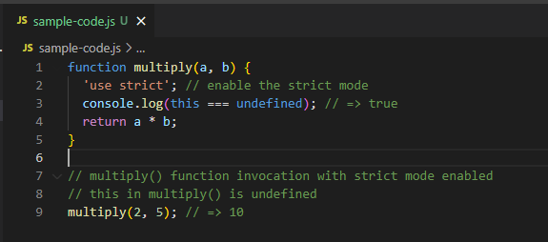

Strict mode in inner scopes:

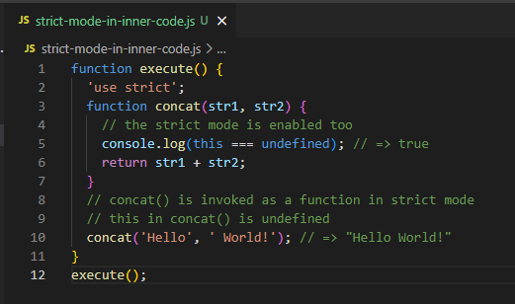

Combination of strict and non-strict mode

